Deep Learning Labs Interview Prep

Lab 3 Exercise 1 – Binary Classifiers

What two datasets are compared in Exercise 1?
Synthetic two-moons data and the Wisconsin Breast Cancer dataset.
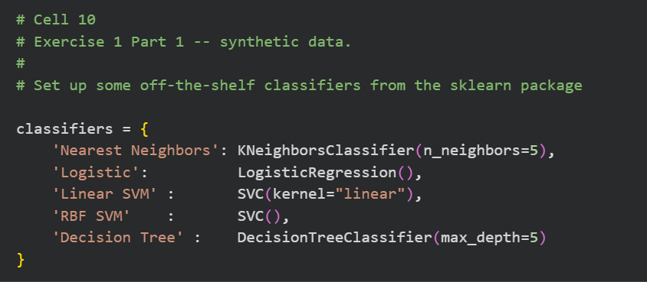
Cell 10 defines different classifiers
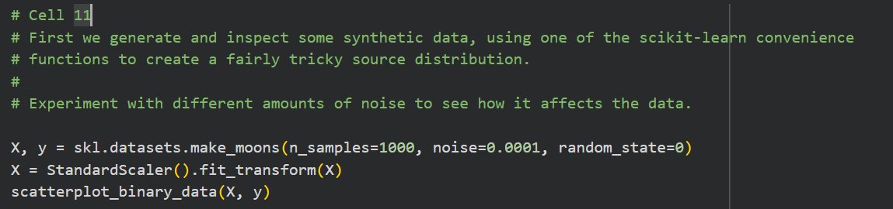
Cell 11 creates moons data
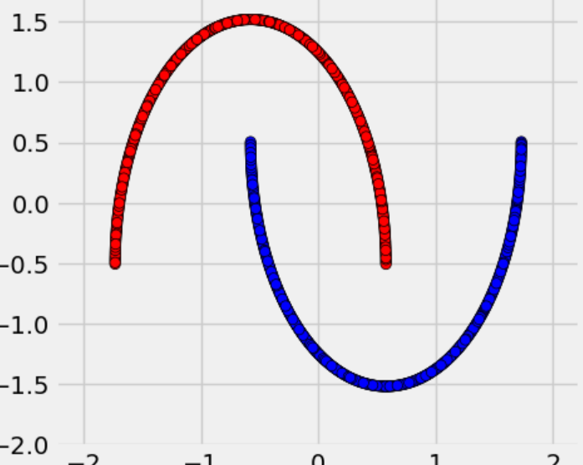
Cell 15 loads breast cancer data
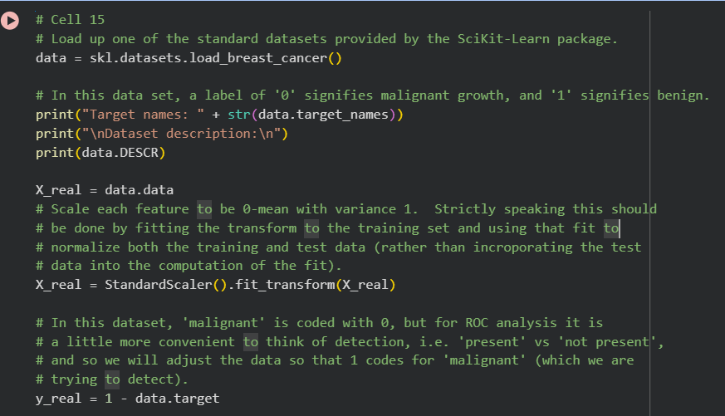

Why is the cancer target flipped with 1 - data.target?
scikit-learn codes malignant as 0, but ROC analysis needs malignant as the positive class, so the code makes malignant equal to 1.
Reference: Cell 15: y_real = 1 - data.target.

How many samples and features are in the breast-cancer dataset?
569 tumours and 30 numeric features; 212 malignant and 357 benign.
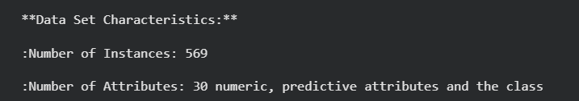

What train/test split is used for breast-cancer data?
A 50/50 split with test_size=0.5 and random_state=0.
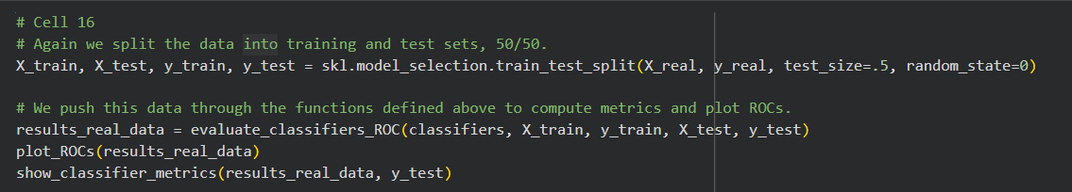
Testing different classifier using imported module…greatest AUC of ROC model means best fit….

Why is the scaling in Cell 15 leakage?
StandardScaler().fit_transform(X_real) is applied before splitting, so test-set mean and variance influence training.

What does question1_() ask
- # Quiz: Which classifier has the highest TPR for an FPR of 15%? (hint: change the axis limits!)
- #
- # Provide your answer in the function 'question_1' in the lab module ('lab_3.py').
Which classifier has the highest TPR at FPR = 0.15 on the synthetic ROC curves.
Answer: Nearest Neighbors.
Reference: Cell 13; lab_3.py::question_1().

7. How does evaluate_classifiers_ROC() obtain a score?
It uses decision_function() where available, otherwise the positive-class probability from predict_proba().
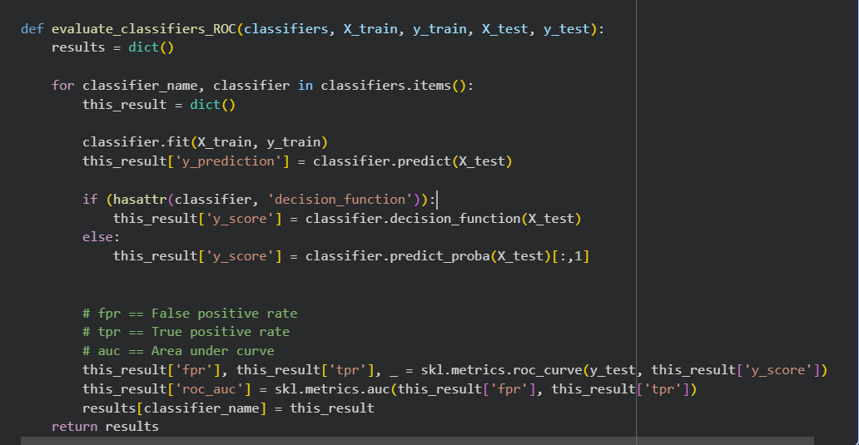

8. Why do Logistic Regression and Linear SVM struggle on two-moons data?
They create linear boundaries, while the two-moons classes require a curved boundary.
Reference: Cell 10 classifier definitions; Cell 12 synthetic results.
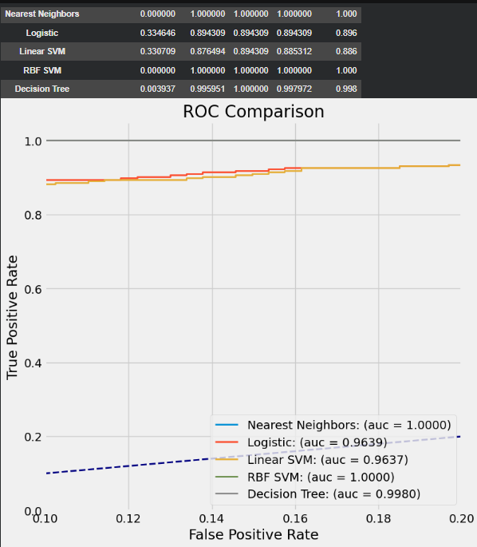
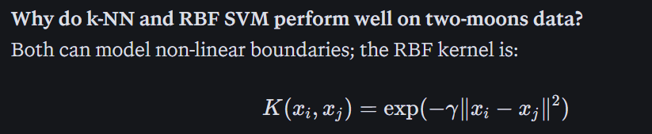

What does question_2() ask?
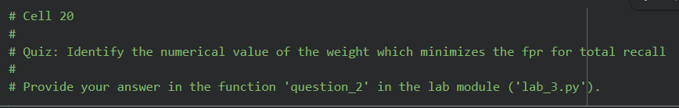
Which numerical malignant-class weight minimises FPR at total recall
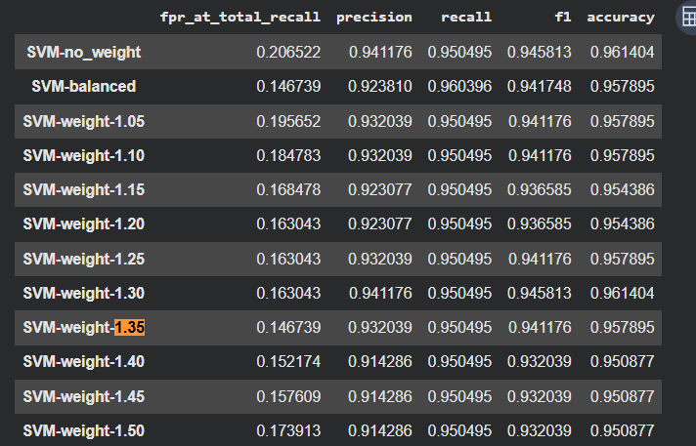
Ans: minimum false positive rate at SVM weight 1.35
What effect did weight 1.35 have?
It reduced FPR at total recall from 0.2065 to 0.1467, about a 29% reduction, while accuracy fell only from 0.961 to 0.958.
Reference: Cell 19 weighted-SVM results table.
Why does weight above 1.35 become worse?
The model predicts malignant too often, increasing false positives; the relationship is non-monotonic.
Reference: Cell 19, weights 1.40–1.50.
Why can Logistic Regression have best accuracy but not best FPR at total recall?
Accuracy is measured at the default threshold, while FPR at total recall is measured at the threshold needed to catch all positives.
Reference: Cell 16 metrics table; Cell 9 metric definition.

Lab 3 Exercise 2

What does question_3() ask?
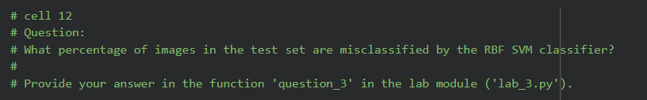
What it asks: return the percentage of test images misclassified by the RBF SVM, as a number from 0 to 100.
The RBF SVM accuracy is in the metrics table produced in Cell 11 (df = pd.DataFrame(metrics).transpose()). In your saved run, RBF SVM accuracy is 0.932.
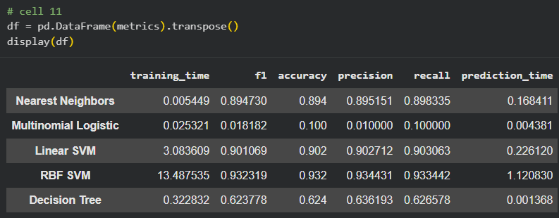
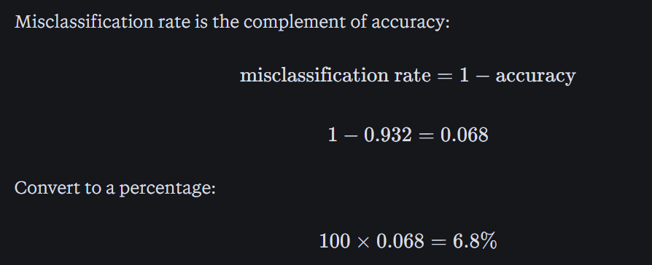
The test sets contains 2000 training and 500 test images…
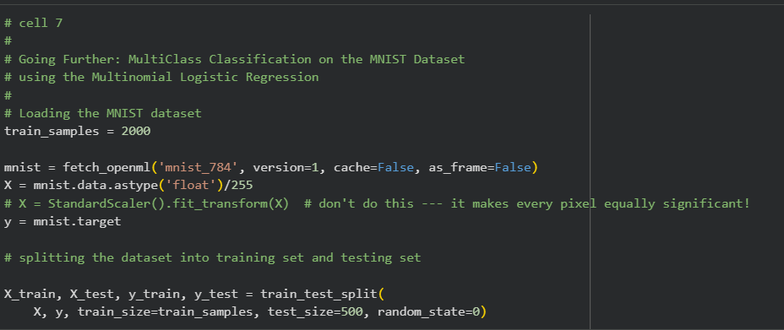
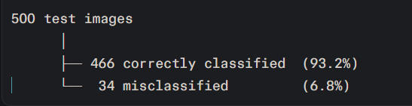

What does question_4() ask?
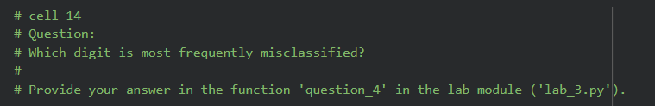
What it asks: identify the digit class with the largest proportion of incorrect predictions under the RBF SVM.
In Cell 13, the notebook computes
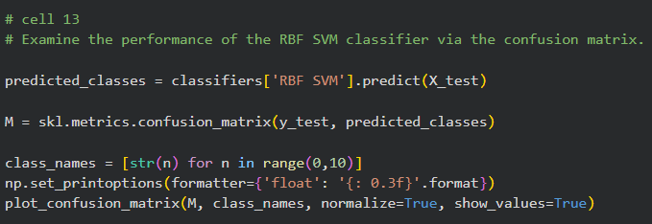
With normalize=True, each row is divided by the number of true examples of that digit. Therefore:
- The diagonal entry $M_{ii}$is the recall for digit $i$.
- An off-diagonal entry $M_{ij}$is the proportion of true digit $i$predicted as digit $j$.
- The digit with the smallest diagonal value is the digit most frequently misclassified, relative to its own test examples.
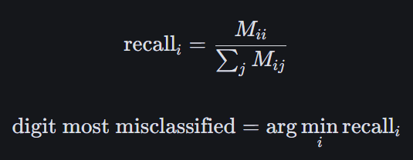
A confusion matrix is a table that shows what a classifier predicted versus what was actually true. Rows are the true labels; columns are the predicted labels.

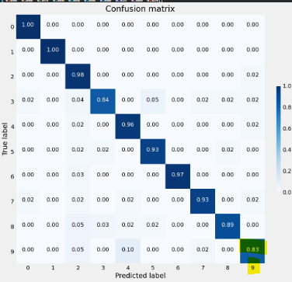
In your confusion matrix, digit 9 has the lowest diagonal value, approximately 0.829, meaning only about 82.9% of true 9s are correctly identified. Digit 3 is close behind at about 0.836. Therefore the answer is digit 9.

Lab 3 Exercise 3

What is the purpose of part 3?
Predictions on a hidden value set. (The final graded artefact is lab3ex3preds.npz, generated from validation.csv)
In Part 3, chosen_model must exactly match a key in PredictionModels, e.g. "Histogram Gradient Boosting"
What it asks: predict SMK_stat_type_cd, where 0 means never-smoker and 1 means active smoker, from 23 biological/clinical input features.
Cell 3: load data/data.csv and shuffle it with DataFrame.sample(frac=1).
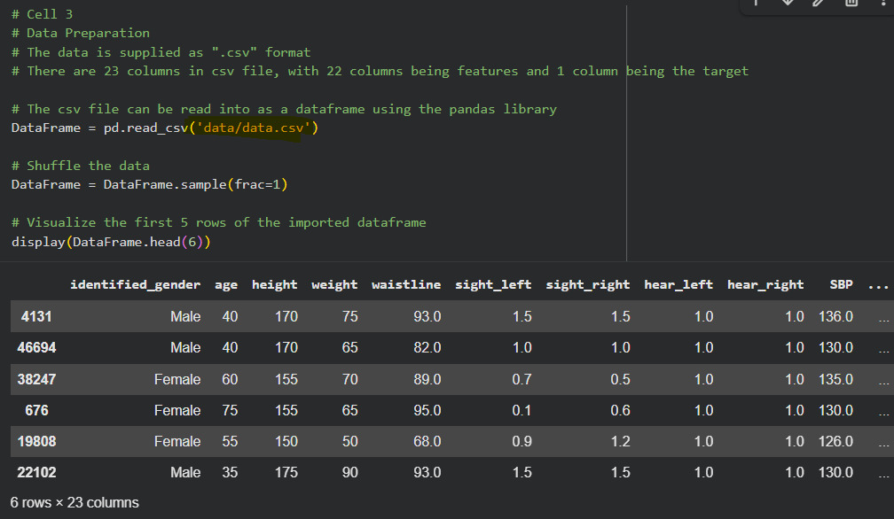
• Cell 4: encode identified_gender: Female → 0, Male → 1, using the same fitted LabelEncoder later for validation data.Lab-3-Ex.-3.ipynb
• Cell 6: separate features DataFrameX from target DataFrameY; the final column, SMK_stat_type_cd, is the target.Lab-3-Ex.-3.ipynb
• Cell 7: split 85% train / 15% test, giving 42,500 training and 7,500 test rows.Lab-3-Ex.-3.ipynb
• Cell 8: fit and compare Logistic Regression, Random Forest, and Histogram Gradient Boosting using F1 score.Lab-3-Ex.-3.ipynb
• Cell 9: set chosen_model to the name of the best model.Lab-3-Ex.-3.ipynb
• Cell 10: encode validation.csv with the same encoder, predict, and save lab3ex3preds.npz
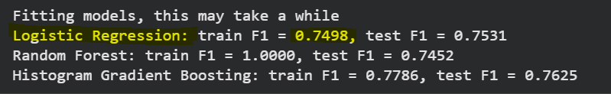
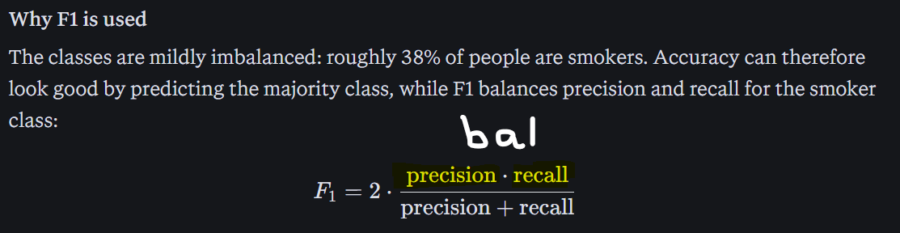

Lab 4 – Image Classification in Pytorch
Contains the entire training pipeline: data loading, augmentation, optimiser, training loop.
Lab 4 uses a fully connected network (FCN), while Lab 5 replaces most dense layers with a convolutional neural network (CNN)
The core ideas are the same—forward pass, cross-entropy loss, backpropagation, and optimizer updates—but Lab 5 adds convolution, pooling, and spatial feature learning.
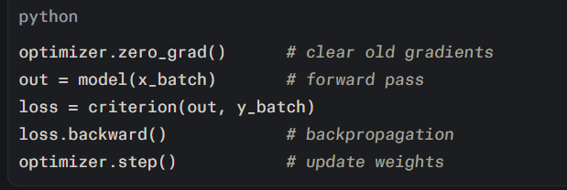
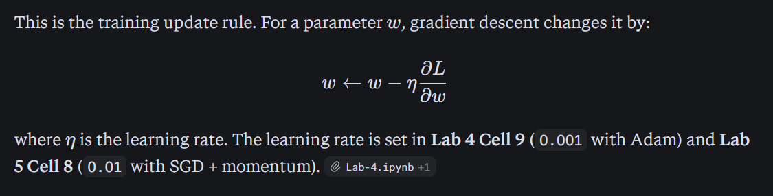
Lab 4 cell 9
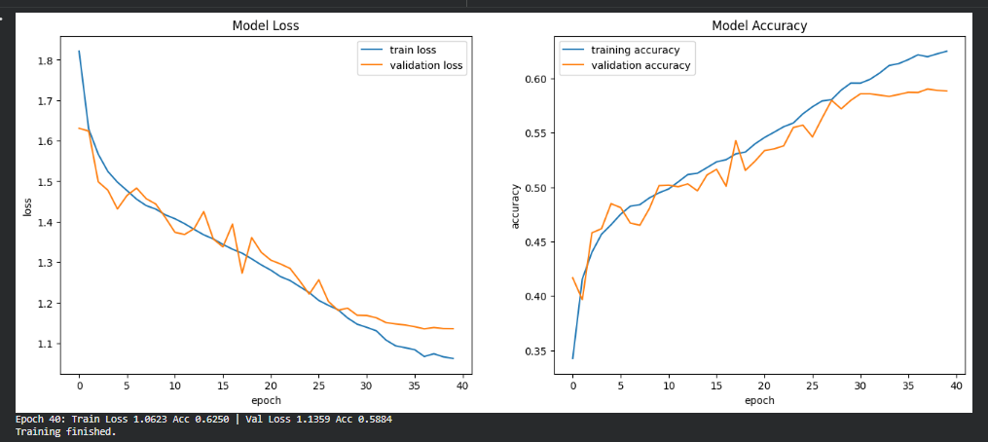
An epoch is one complete pass through the entire training dataset. In Labs 4 and 5, one epoch means the model sees all 45,000 CIFAR-10 training images once, in mini-batches.
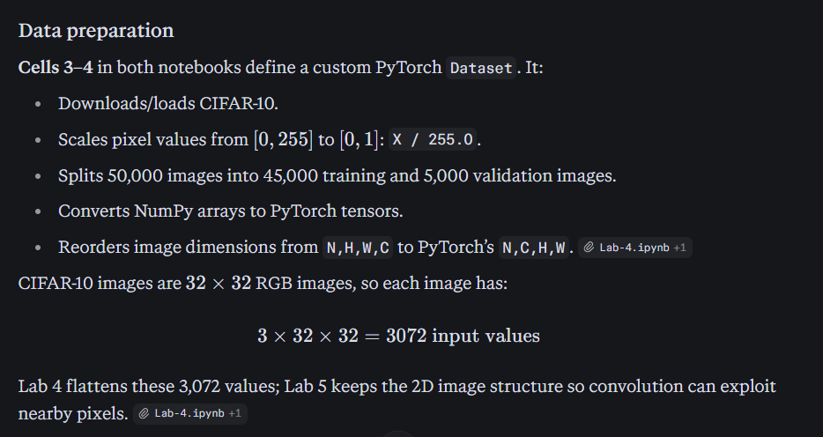
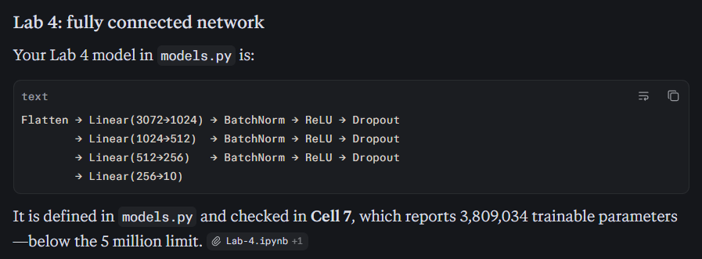
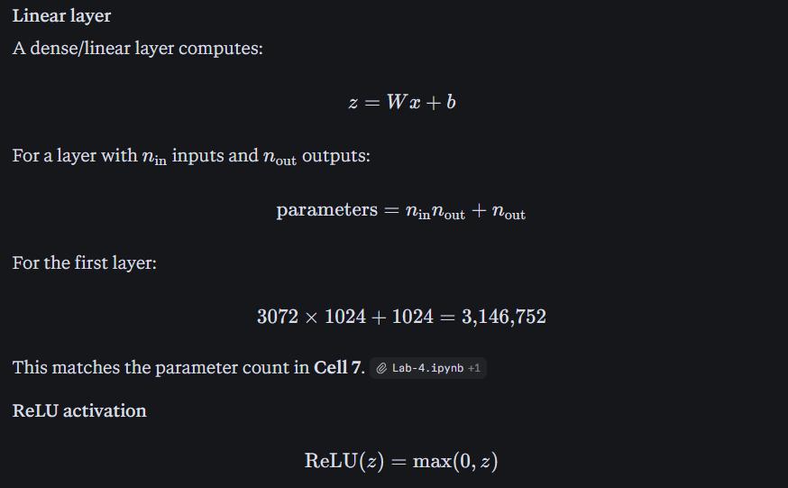
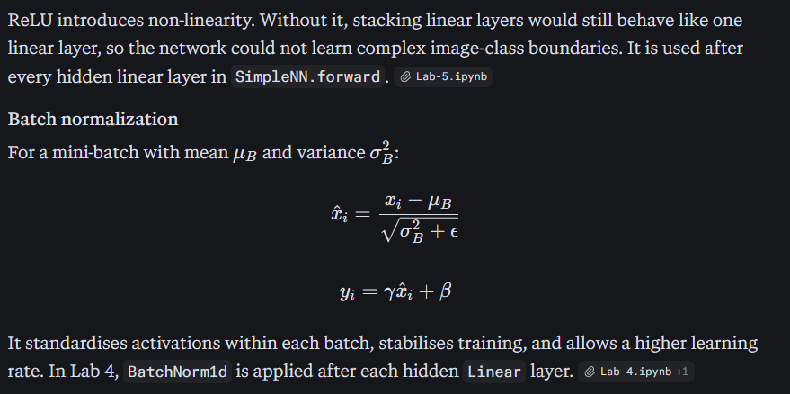
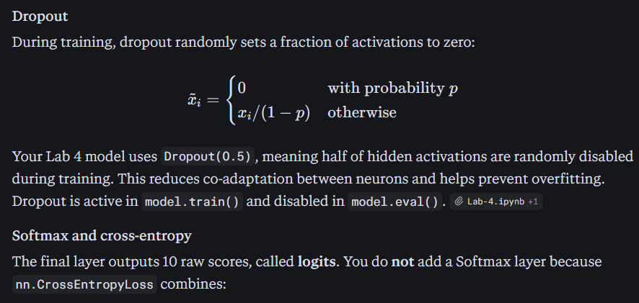
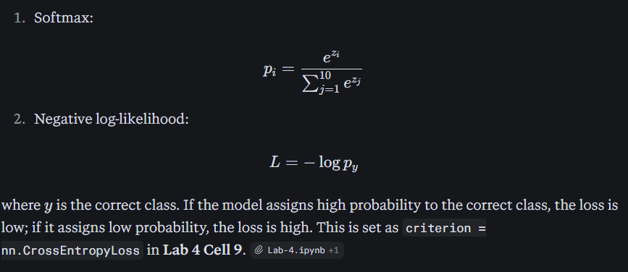
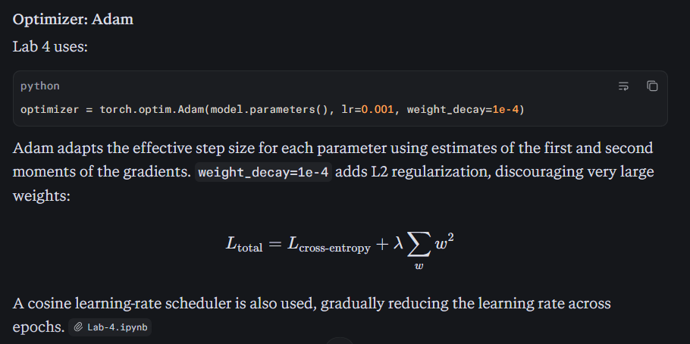

Lab 5 – Image Classification in Pytorch Convnet


